***Sql queries***

***For Q1 to Q15:***

create table emp1

(

empno int primary key,

empname varchar(20),

deptid varchar(12),

salary int,

deptno int,

city varchar(20)

);

insert into emp1 values (100, 'Jyoti', 'da', 4000, 10, 'Jaipur');

insert into emp1 values (101, 'Eugene', 'db', 5000, 10, 'Delhi');

insert into emp1 values (102, 'Kirti', 'dc', 3000, 20, 'Lucknow');

insert into emp1 values (103, 'Tony', 'dd', 8000, 30, 'Kanpur');

insert into emp1 values (104, 'Jack', 'de', 7000, 80, 'Jhansi');

insert into emp1 values (105, 'Riya', 'df', 8000, 20, 'Varanasi');

insert into emp1 values (106, 'Kajal', 'dg', 10000, 10, 'Gurgaon');

insert into emp1 values (107, 'Misha', 'da', 9000, 15, 'Kerala');

insert into emp1 values (108, 'Nisha', 'db', 14000, 10, 'Orissa');

insert into emp1 values (109, 'Yashi', 'dc', 54000, 70, 'Lucknow');

insert into emp1 values (110, 'Kirti', 'dd', 44000, 60, 'Delhi')

insert into emp1 values (111, 'Yogita', 'de', 46000, 70, 'Noida');

insert into emp1 values (112, 'Sonam', 'df', 87000, 20, 'Agra');

insert into emp1 values (113, 'Sonali', 'dg', 21000, 40, 'Delhi');

insert into emp1 values (114, 'Kiya', 'db', 7600, 30, 'Kanpur');

insert into emp1 values (115, 'Ritu', 'df', 98000, 20, 'Lucknow');

insert into emp1 values (116, 'Ram', 'da', 8800, 70, 'Lucknow');

Q1) Write a SQL Query to list all employees whose salary is greater than or equal to 5000.

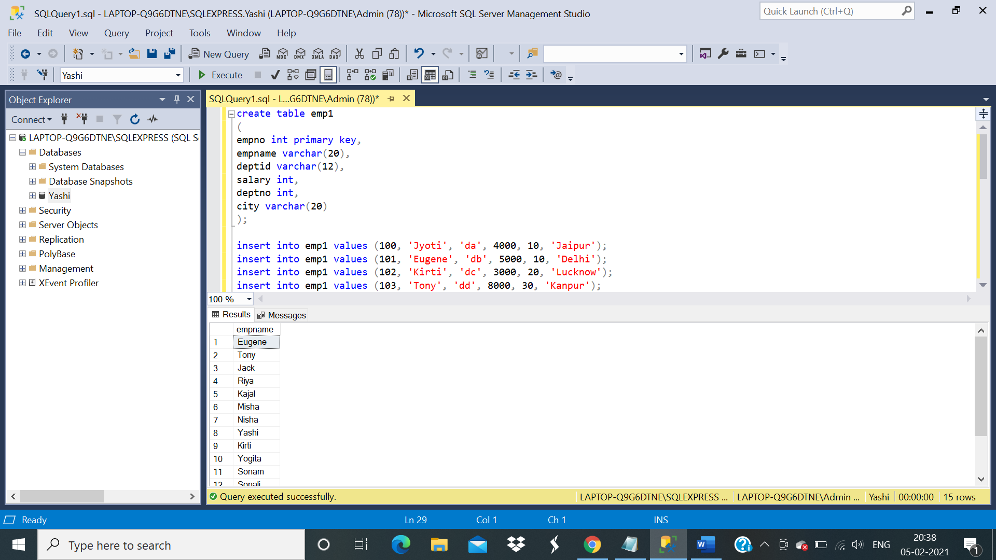 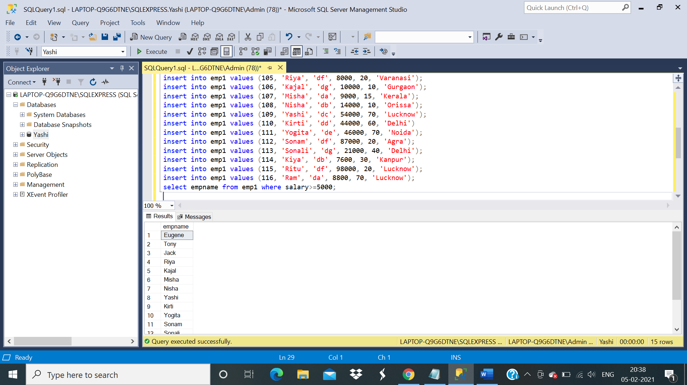

Q2) A sql query to list all employees not entitled for commission.

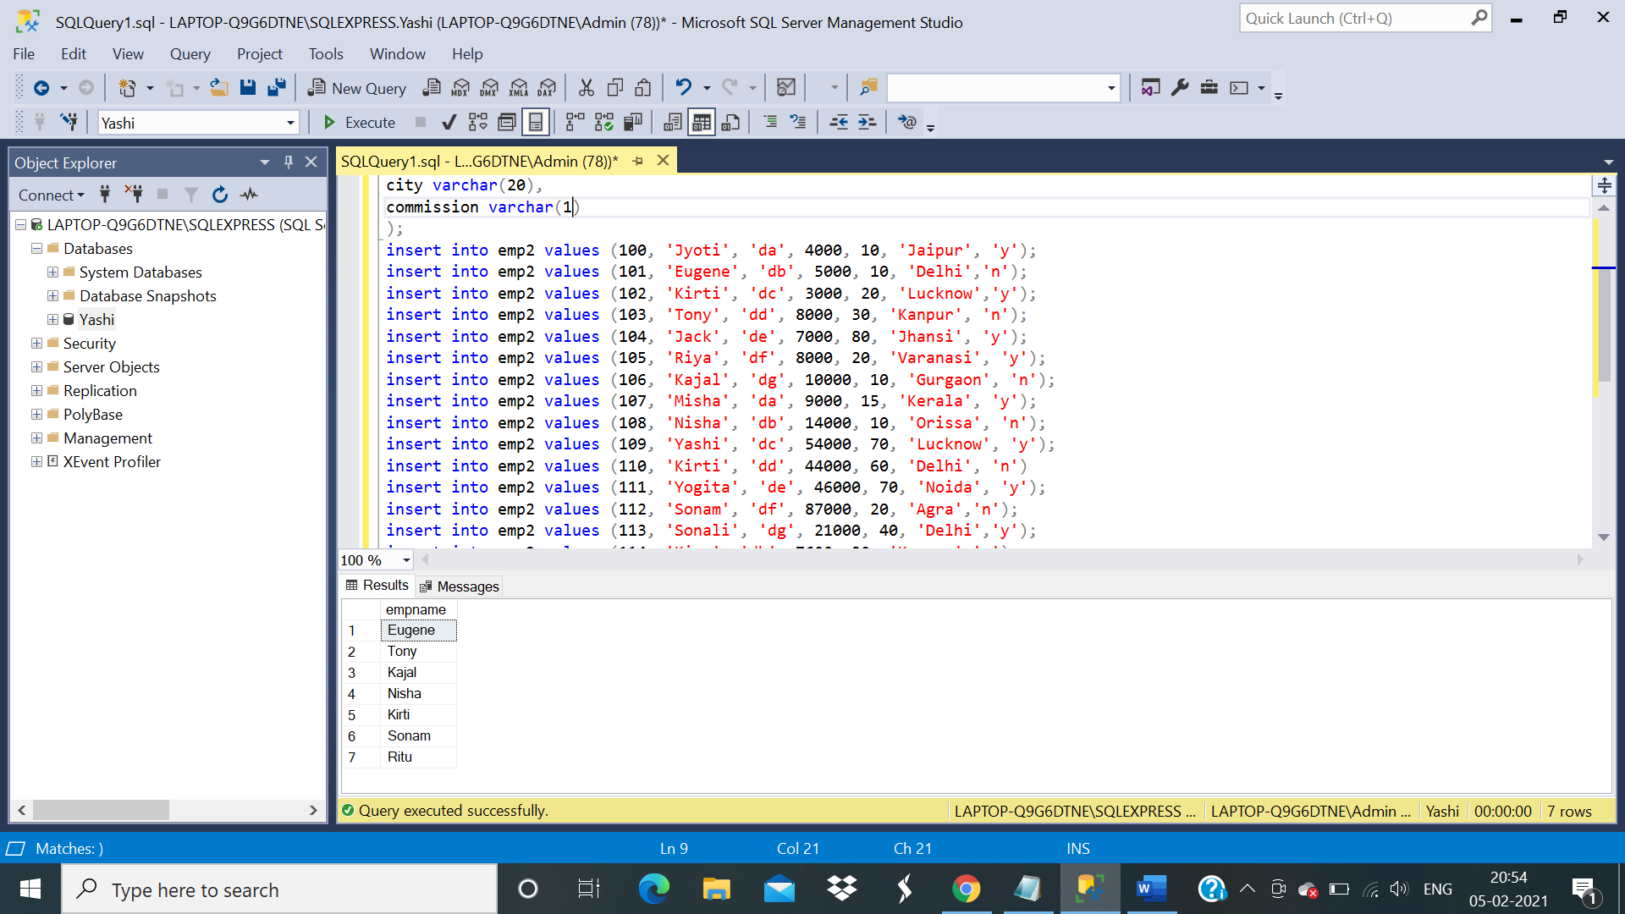 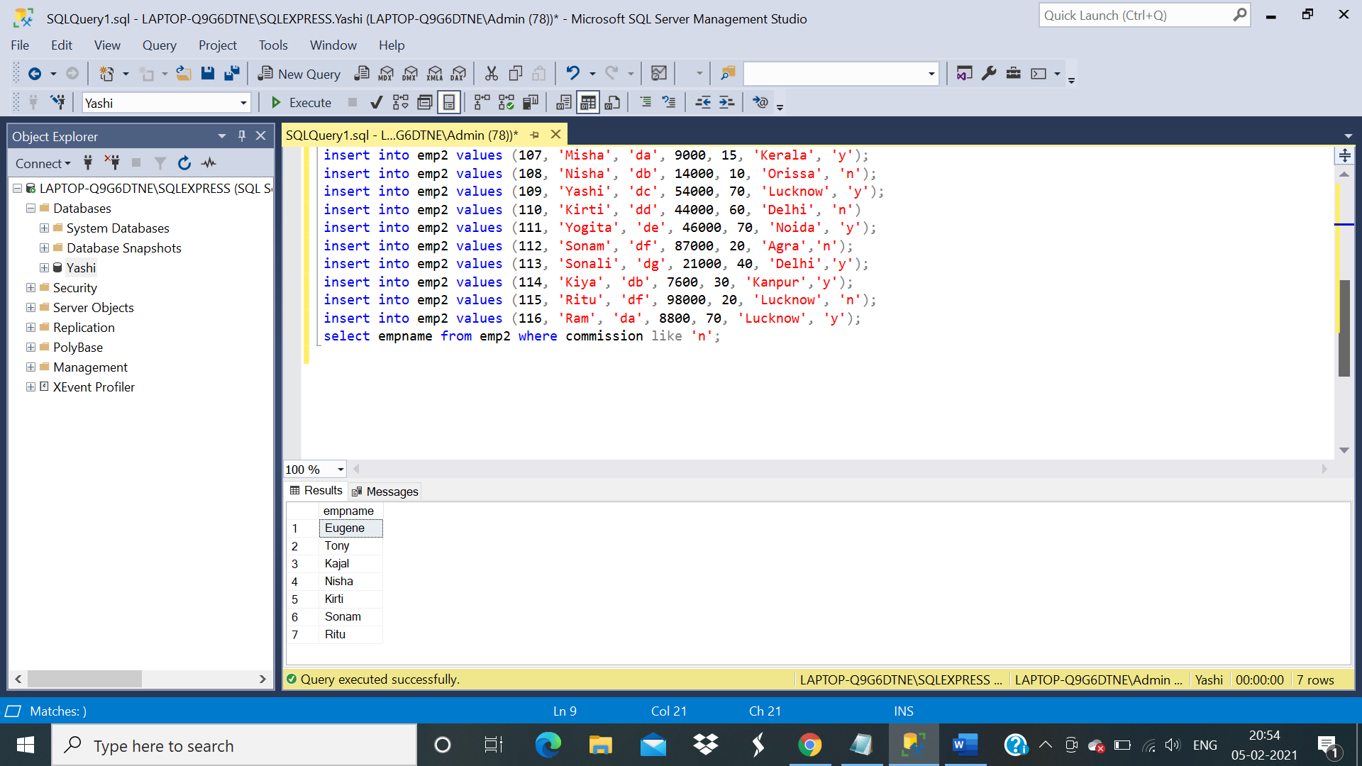

Q3) A sql query to list all employees who receive commission.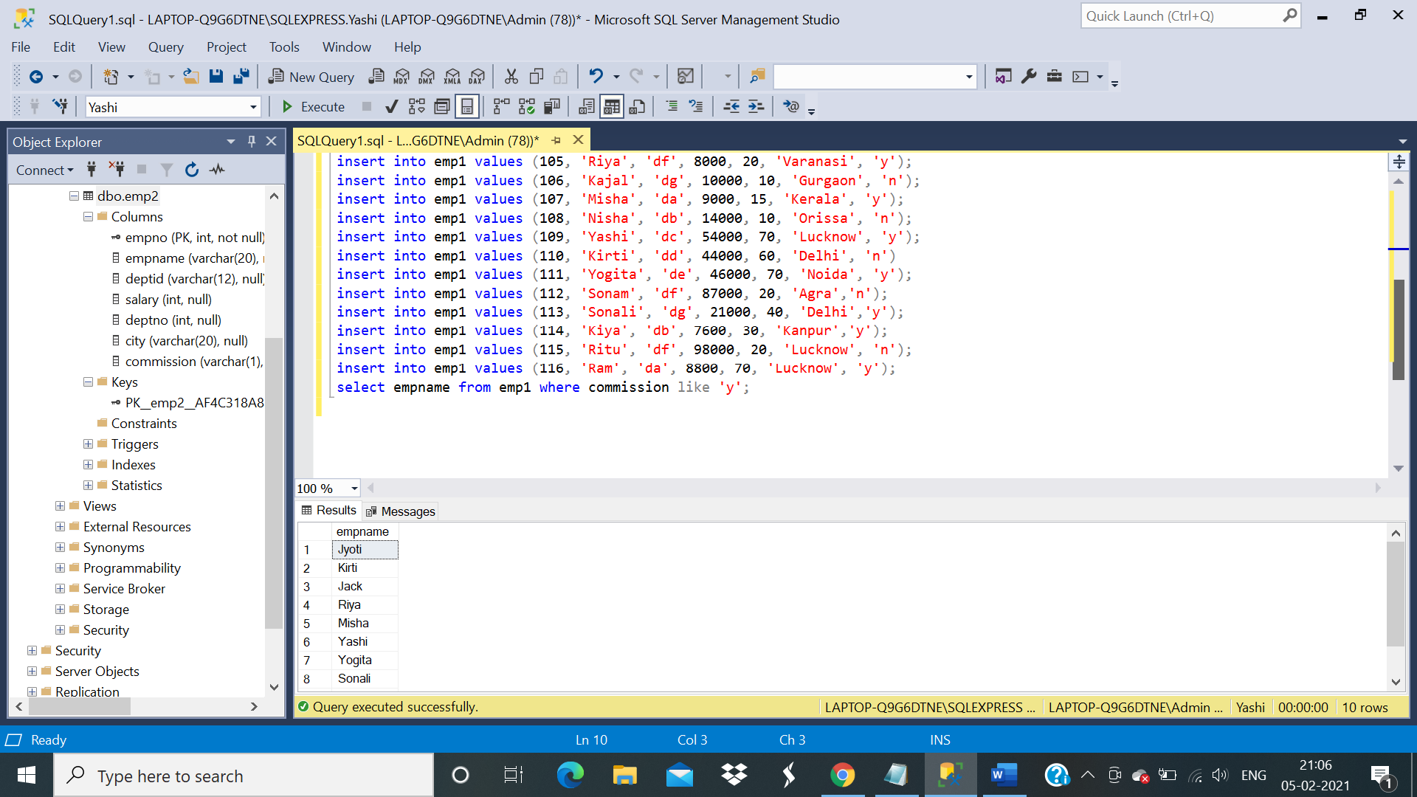

Q4) To list all employees whose name begins with ‘J’.

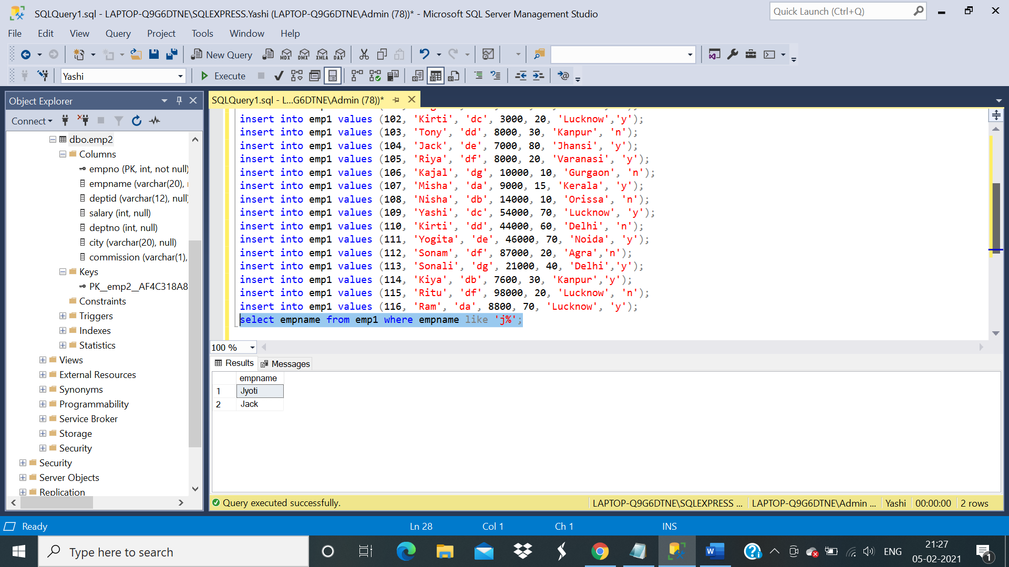

Q5) To find out average, minimum and maximum salary of each department by department id.

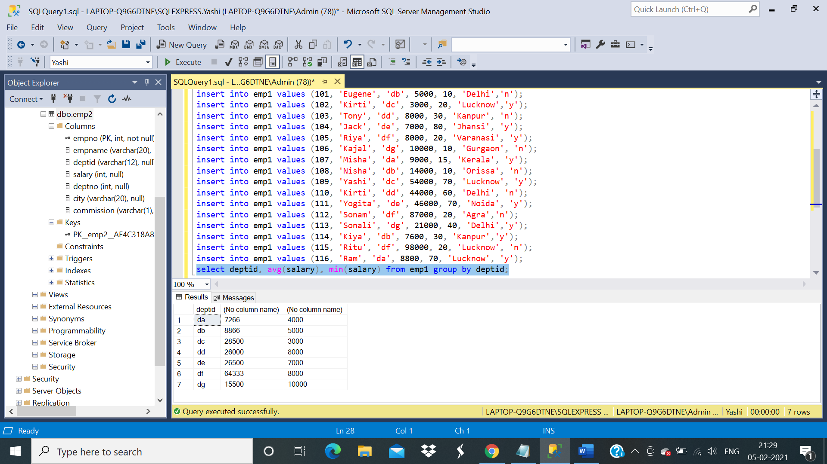

Q6) To get all employees from dept 10 and 20.

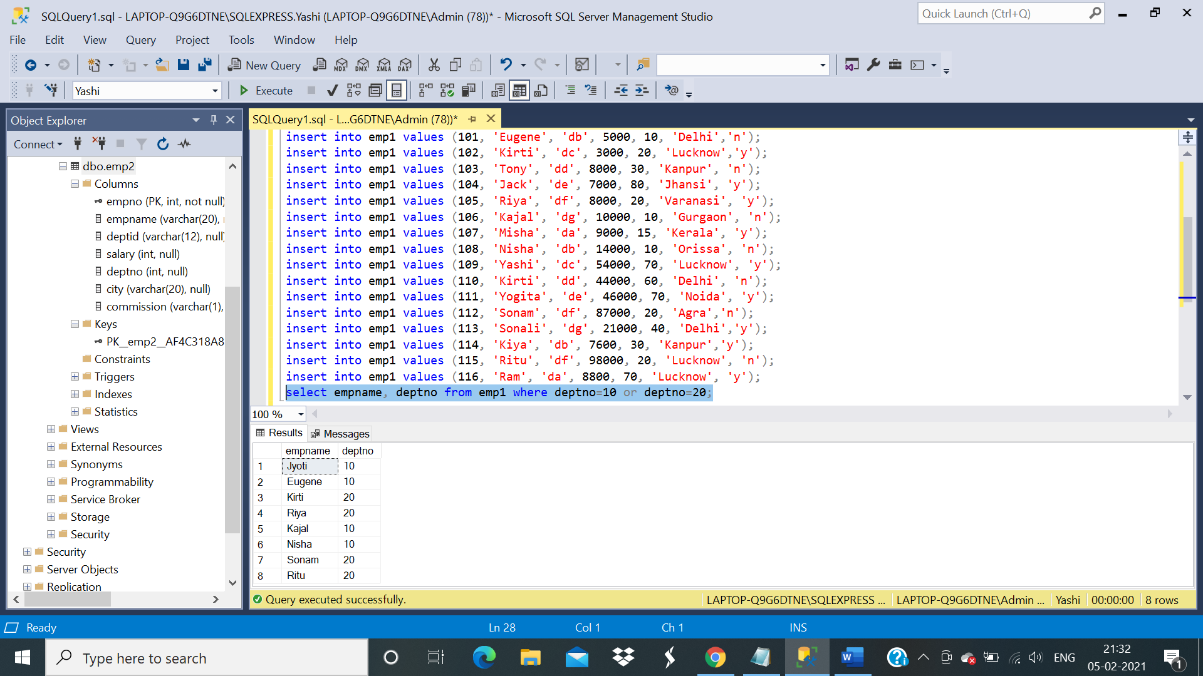

Q7) To get all employees along with their annual salary sorted on the basis of annual salary.

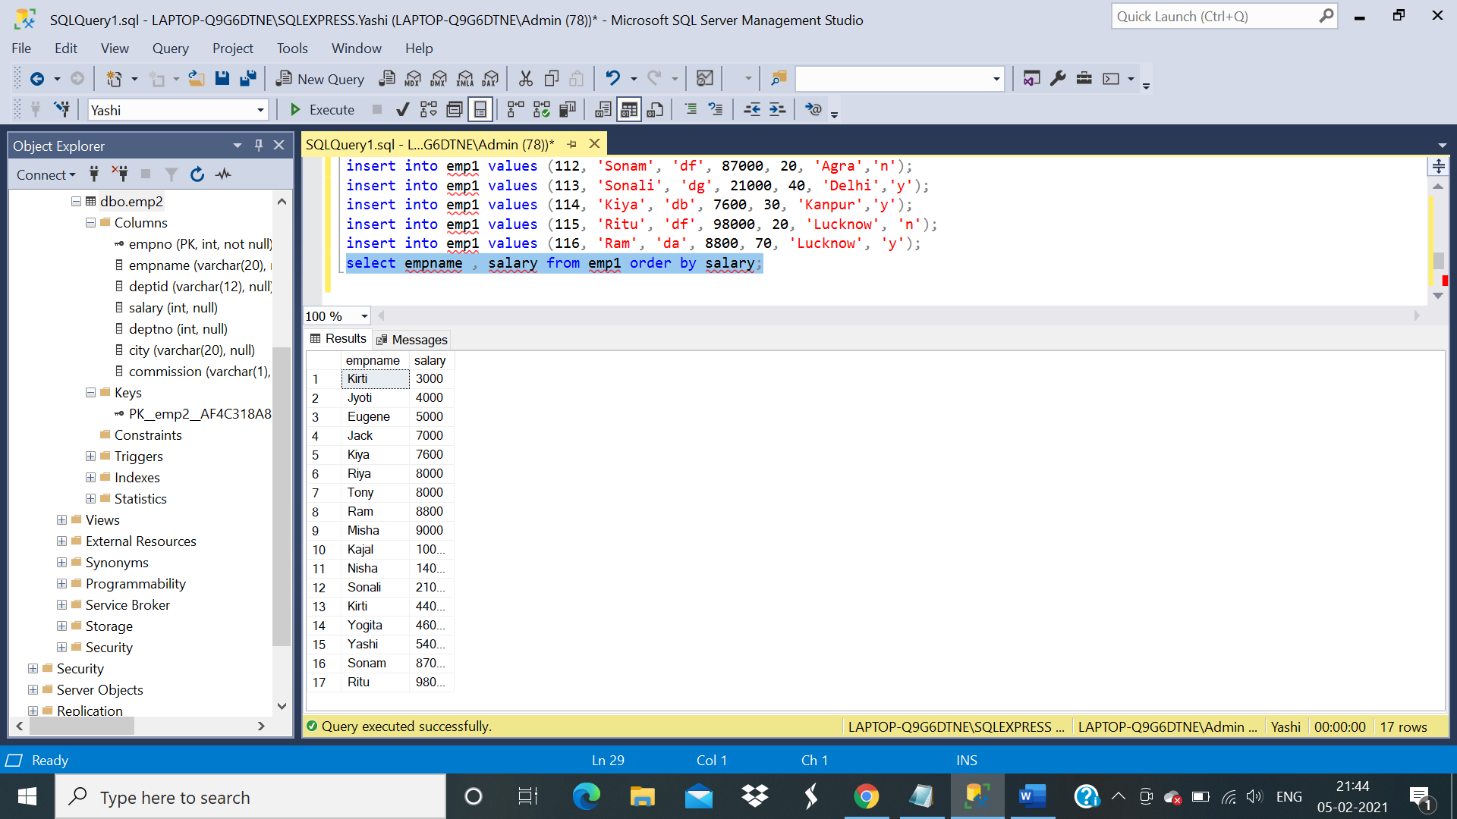

Q8)To list all employees working in department other than 10.

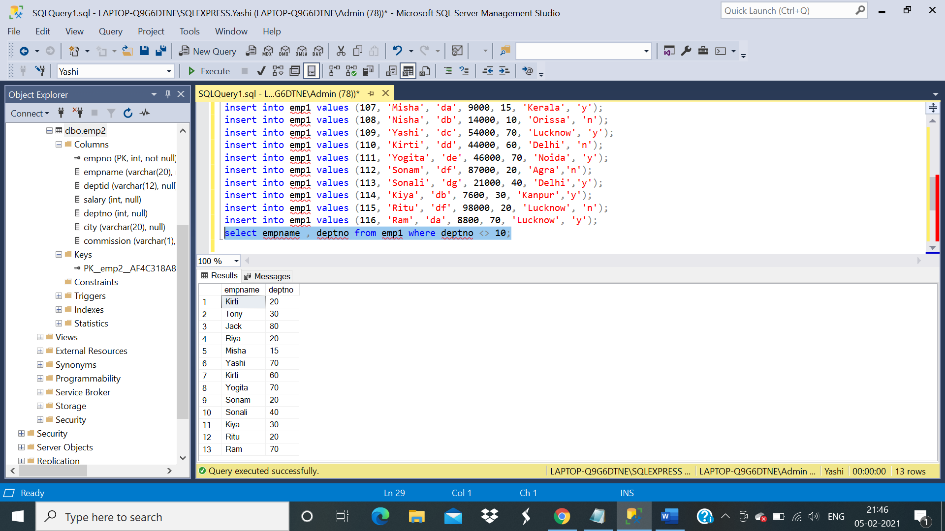

Q9)To find the minimum salaries of various categories of employees in various departments.

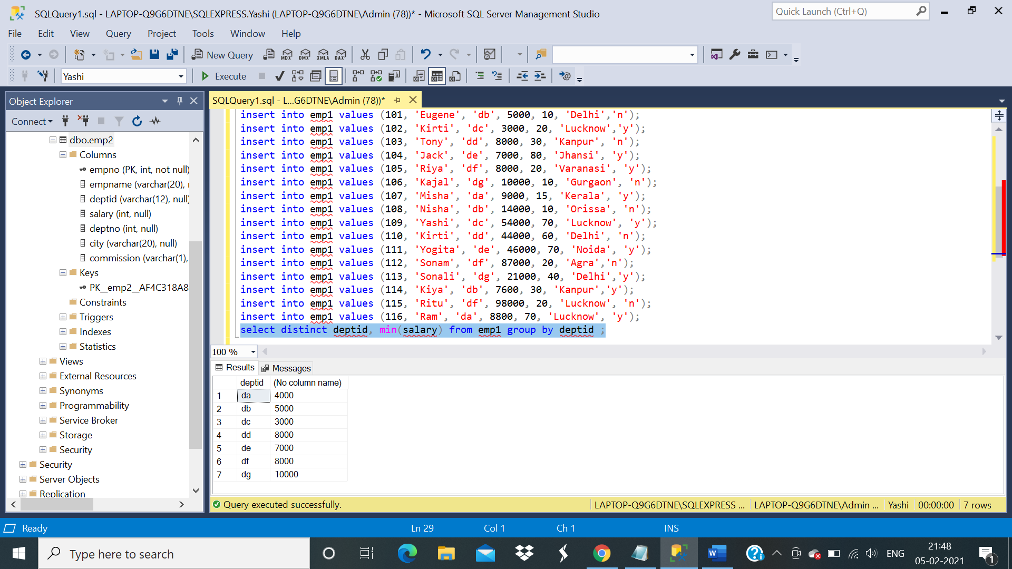

Q10) To list all employees in the ascending order by name.

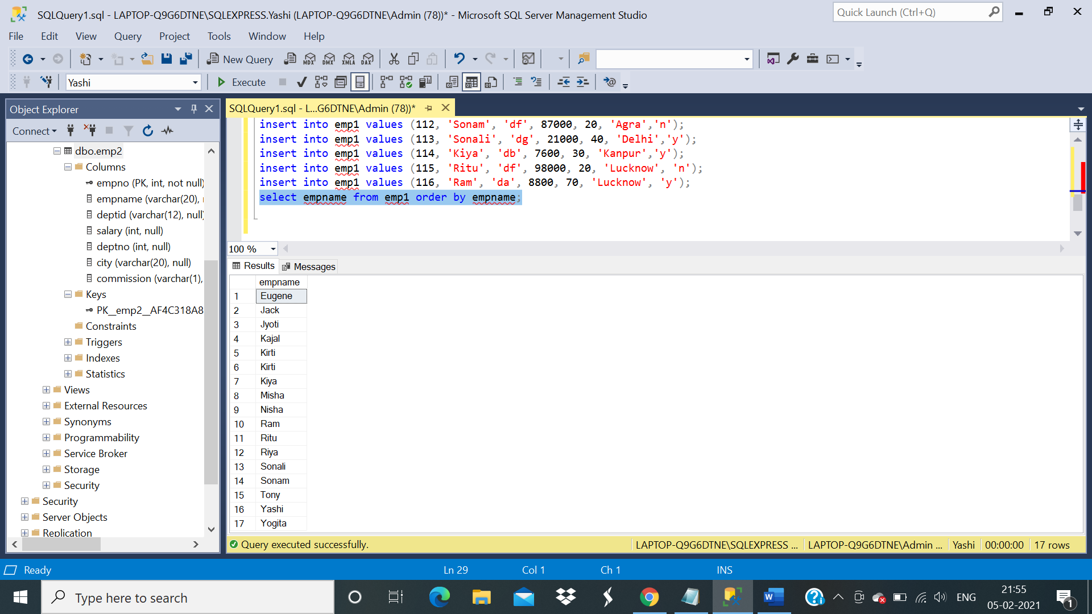

Q11) To list all employees sorted dept wise and in ascending order .

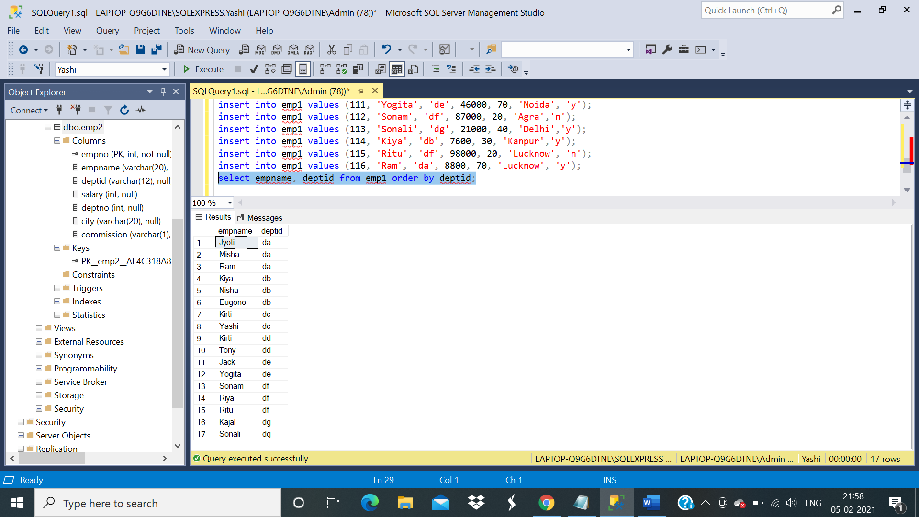

Q12) To list employees whose name begins with ‘S’ and has ‘N’ as the third character.

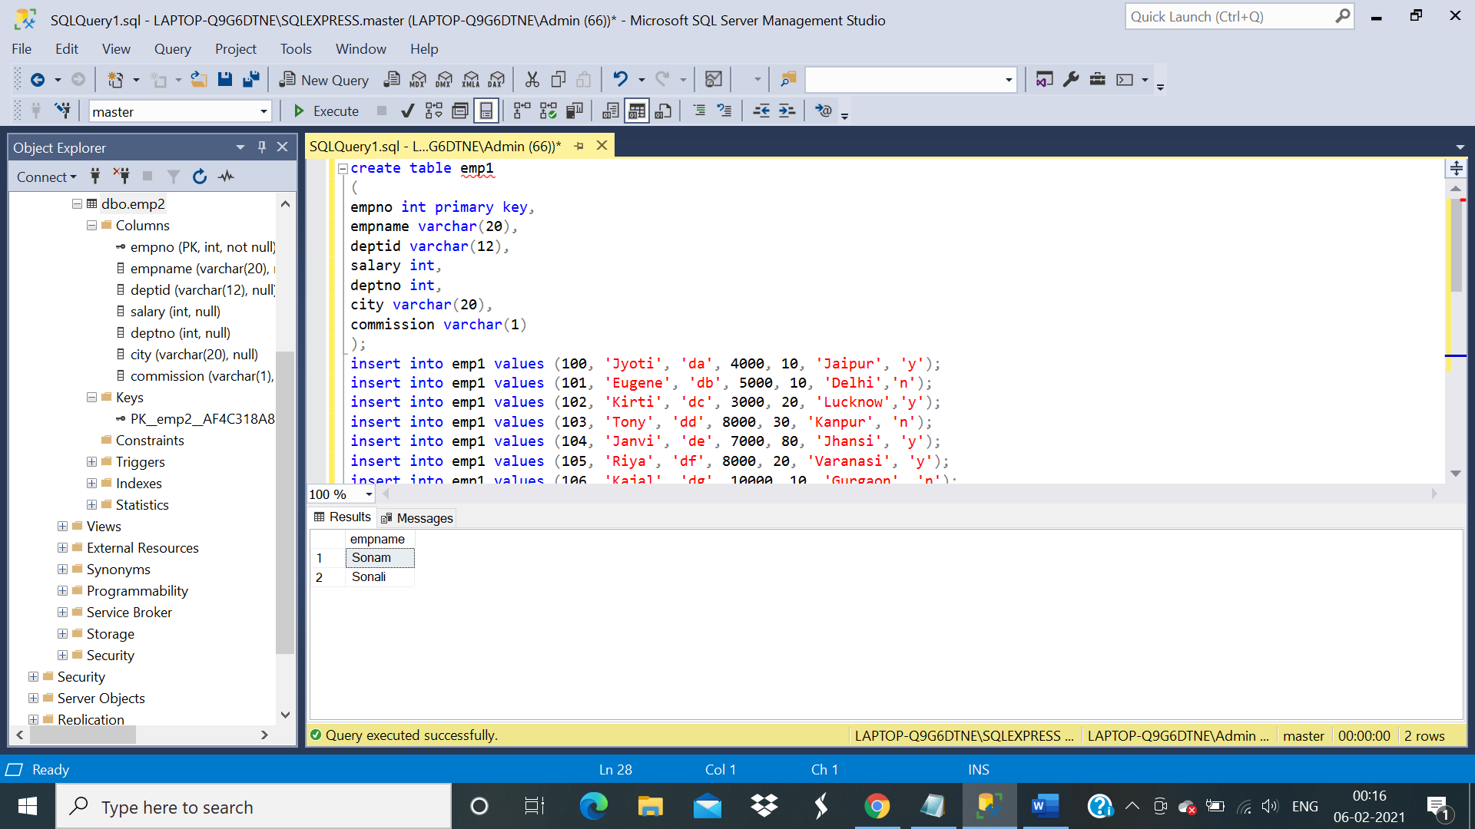 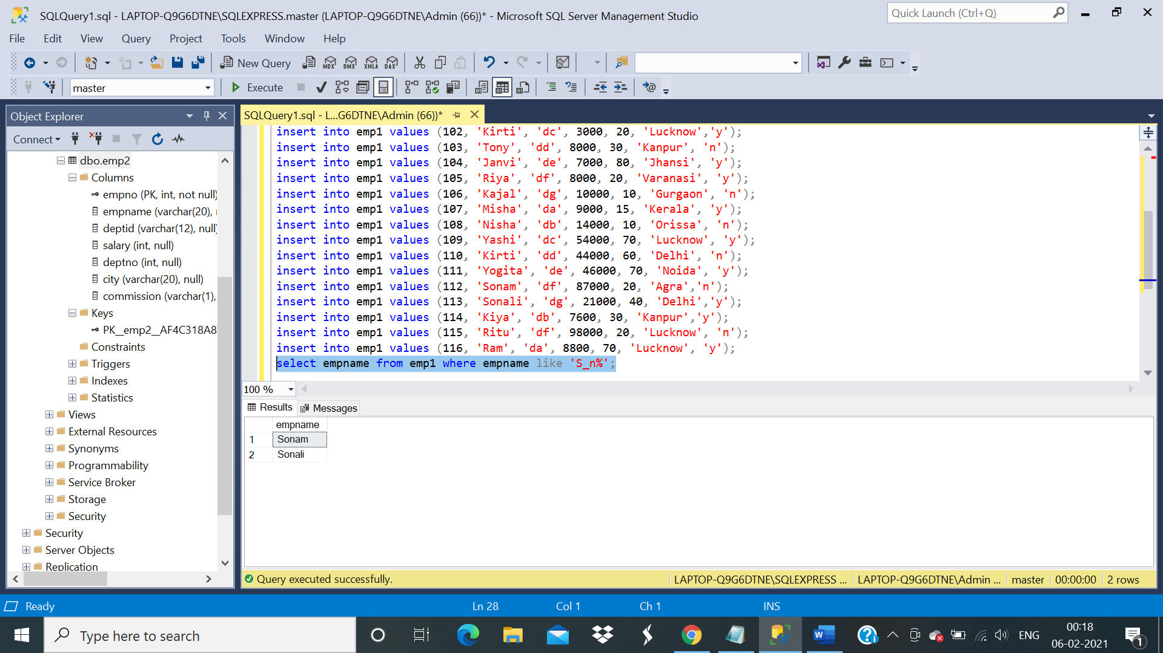

Q13)To get all employees from department 10 and 20.

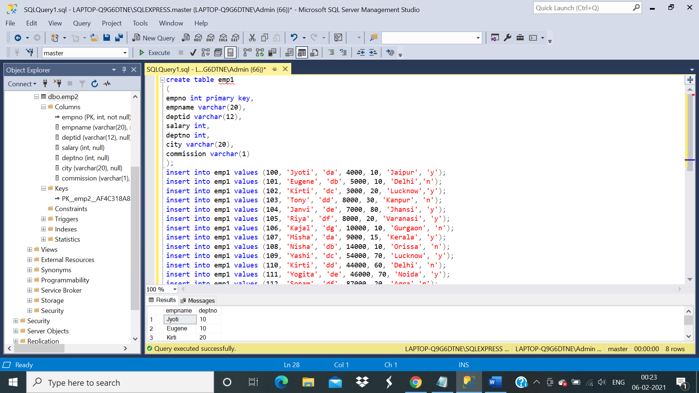 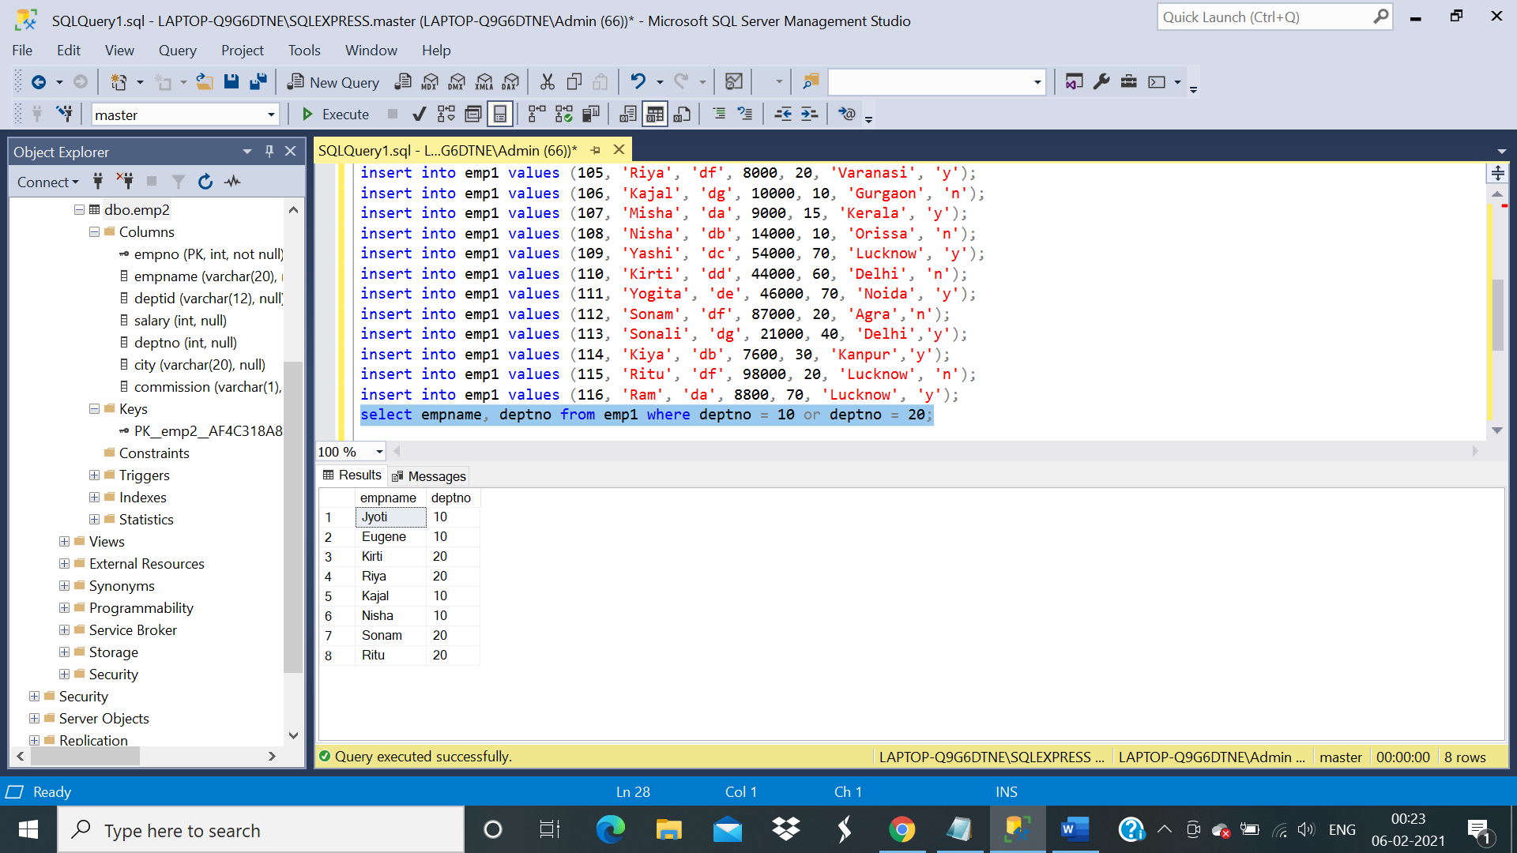

Q14) To select all employees sorted dept wise in ascending order and within dept salary wise in descending order.

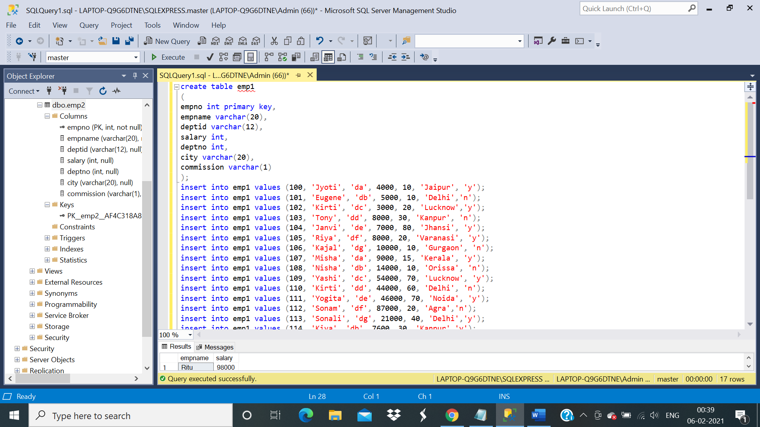 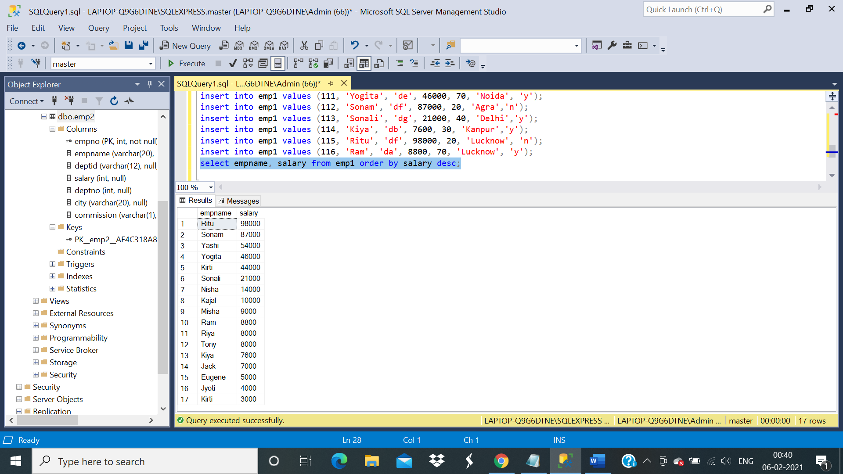

Q15) To select all employees along with their annual salary sorted on the basis of annual salary.

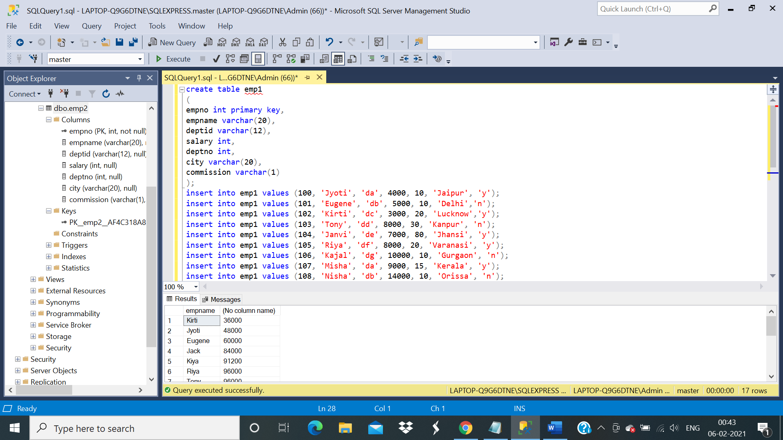 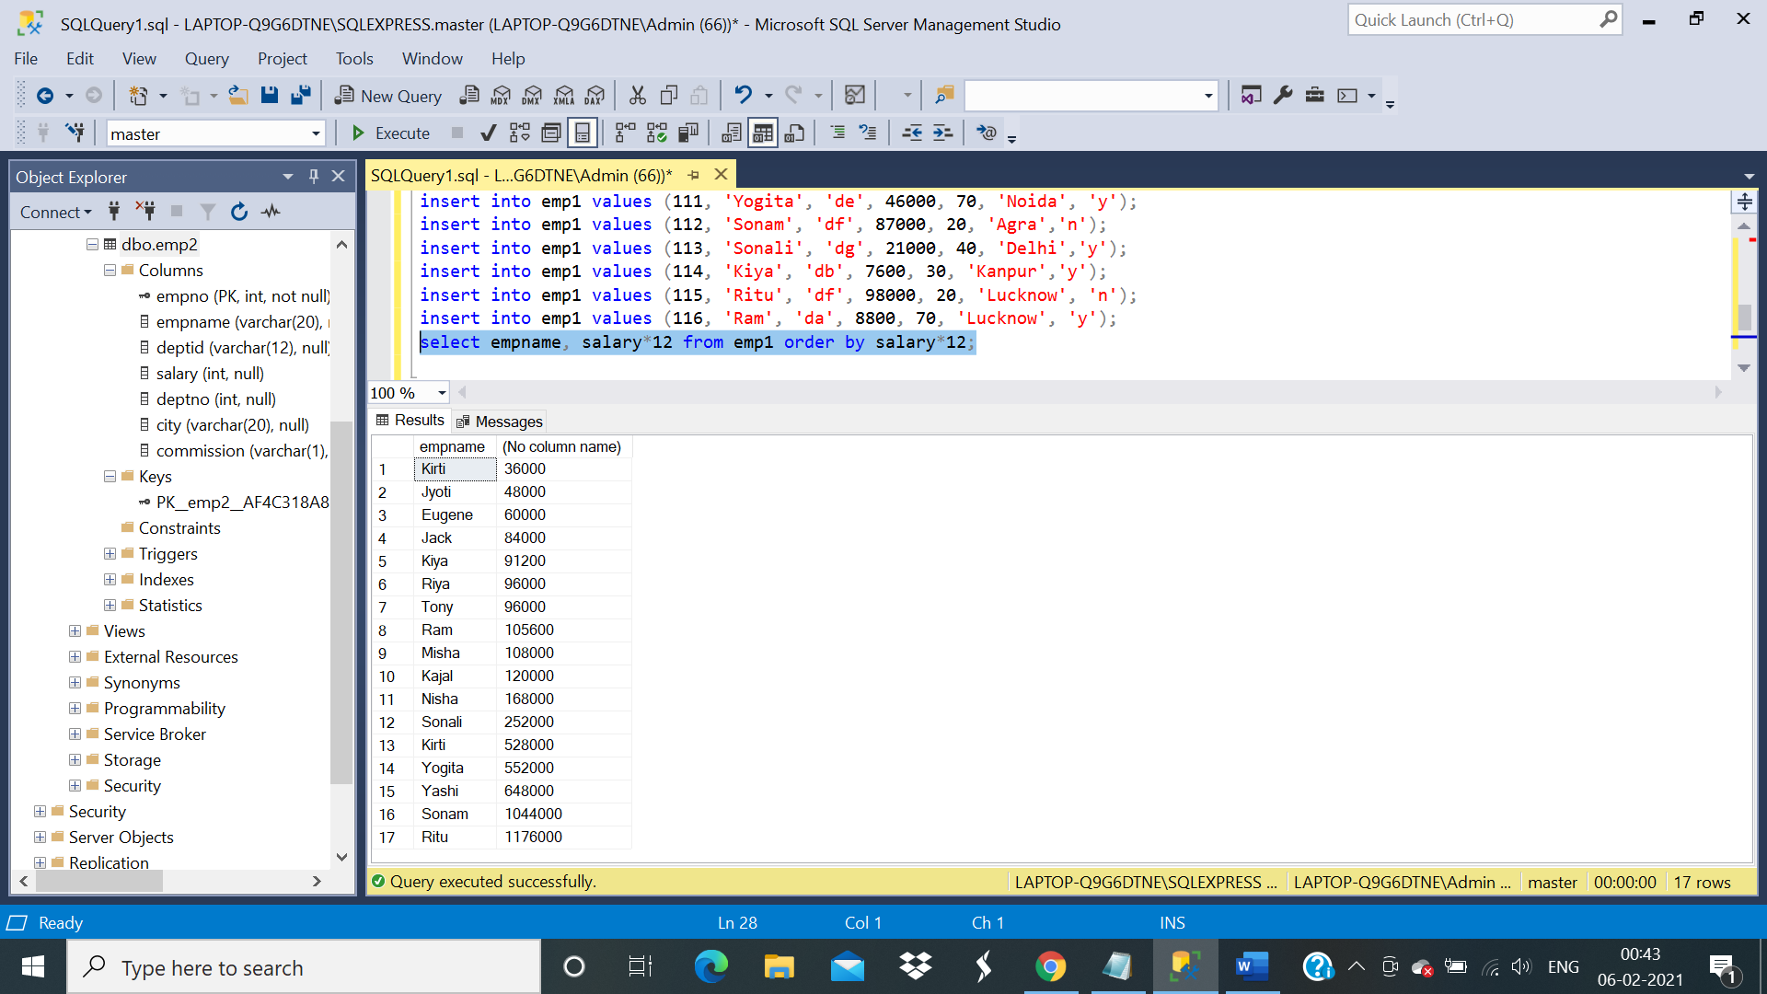

***For Q16 to Q :***

CREATE TABLE EMPLOYEE (

EMP_ID INT NOT NULL PRIMARY KEY ,

FIRST_NAME VARCHAR(50),

LAST_NAME VARCHAR(50),

SALARY INT,

JOINING_DATE DATETIME,

DEPARTMENT VARCHAR(25)

);

INSERT INTO EMPLOYEE

(EMP_ID, FIRST_NAME, LAST_NAME, SALARY, JOINING_DATE, DEPARTMENT) VALUES

(001, 'Siya', 'Pandey', 100000, '2020-04-15 09:00:00', 'HR'),

(002, 'Astha', 'Mishra', 80000, '2020-06-11 09:00:00', 'Admin'),

(003, 'Vishal', 'Singh', 300000, '2020-02-20 09:00:00', 'HR'),

(004, 'Amitabh', 'Verma', 500000, '2020-02-14 09:00:00', 'Admin'),

(005, 'Nalini ', 'Singh', 500000, '2020-06-11 09:00:00', 'Admin'),

(006, 'Yashi', 'Sharma', 200000, '2019-05-11 09:00:00', 'Account'),

(007, 'Deepanjali', 'Bisht', 75000, '2019-01-01 09:00:00', 'Account'),

(008, 'Himani', 'Singh', 90000, '2019-04-04 09:00:00', 'Admin');

SELECT * FROM EMPLOYEE

CREATE TABLE Bonus (

EMP_REF_ID INT,

BONUS_AMOUNT INT,

BONUS_DATE DATE,

FOREIGN KEY (EMP_REF_ID)

REFERENCES EMPLOYEE(EMP_ID)

ON DELETE CASCADE

);

INSERT INTO Bonus

(EMP_REF_ID, BONUS_AMOUNT, BONUS_DATE) VALUES

(001, 5000, '2020-02-20'),

(002, 3000, '2020-06-11'),

(003, 4000, '2020-02-25'),

(001, 4500, '2019-02-23'),

(002, 3500, '2019-06-12');

CREATE TABLE Title (

EMP_REF_ID INT,

EMP_TITLE CHAR(25),

AFFECTED_FROM DATETIME,

FOREIGN KEY (EMP_REF_ID)

REFERENCES EMPLOYEE(EMP_ID)

ON DELETE CASCADE

);

INSERT INTO Title

(EMP_REF_ID, EMP_TITLE, AFFECTED_FROM) VALUES

(001, 'Manager', '2016-02-20 00:00:00'),

(002, 'Executive', '2016-06-11 00:00:00'),

(008, 'Executive', '2016-06-11 00:00:00'),

(005, 'Manager', '2016-06-11 00:00:00'),

(004, 'Asst. Manager', '2016-06-11 00:00:00'),

(007, 'Executive', '2016-06-11 00:00:00'),

(006, 'Lead', '2016-06-11 00:00:00'),

(003, 'Lead', '2016-06-11 00:00:00');

#### Q16) Write an SQL query to fetch “FIRST_NAME” from EMPLOYEE table using the alias name as <EMPLOYEE_NAME>.

#### 

#### 

#### Q17) Write an SQL query to fetch “FIRST_NAME” from EMPLOYEE table in upper case.

#### 

#### Q18) Write an SQL query to fetch unique values of DEPARTMENT from EMPLOYEE table.

#### 

#### Q19) Write an SQL query to print the first three characters of  FIRST_NAME from EMPLOYEE table.

#### 

#### Q20) Write an SQL query that fetches the unique values of DEPARTMENT from EMPL0YEE table.

#### 

#### Q21) Write an SQL query to print the FIRST_NAME from Worker table after replacing ‘a’ with ‘A’.

#### 

#### Q22) Write an SQL query to print the FIRST_NAME and LAST_NAME from EMPLOYEE table into a single column COMPLETE_NAME. A space char should separate them.

#### Q23) Write an SQL query to print all Employee details from the EMPLOYEE table order by FIRST_NAME Ascending.

#### 

#### Q24) Write an SQL query to print all Employee details from the EMPLOYEE table order by FIRST_NAME Ascending and DEPARTMENT Descending.

#### 

#### Q25) Write an SQL query to print details for Workers with the first name as “Siya” and “Yashi” from EMPLOYEE table.

#### 

#### Q26)  Write an SQL query to print details of employees excluding first names, “Siya” and “Yashi” from EMPLOYEE table.

#### 

#### Q27) Write an SQL query to print details of Employees with DEPARTMENT name as “Admin”.

#### 

#### Q28) Write an SQL query to print details of the Employees whose FIRST_NAME contains ‘a’.

#### 

#### Q29)  Write an SQL query to print details of the Employees whose FIRST_NAME ends with ‘a’.

#### 

#### Q30)  Write an SQL query to print details of the Workers whose FIRST_NAME ends with ‘i’ and contains five alphabets.

#### 